Now you are going to make your map with the largest cocoa/tea/banana/coffee countries in the world. Follow the instructions.
You can see a map.
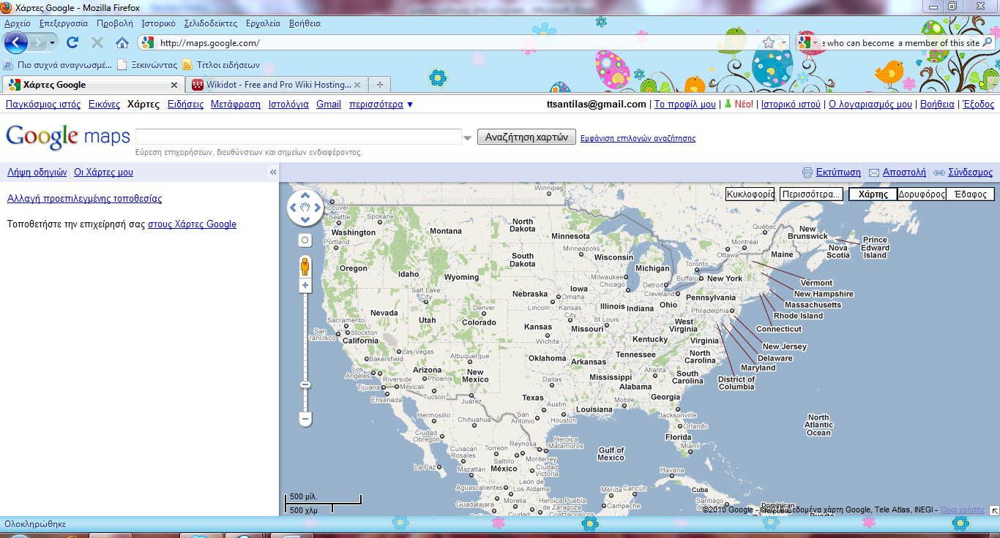
- Use the zoom control to zoom in/out.
- Left click your mouse and drag it left/right to move on the map.
- Click Satellite to have a satellite view of the world.
- Click Maps to have a view of the world.
Now you are going to mark on this map the largest cocoa/tea/banana/coffee countries in the world.
- Click My Maps on the left.
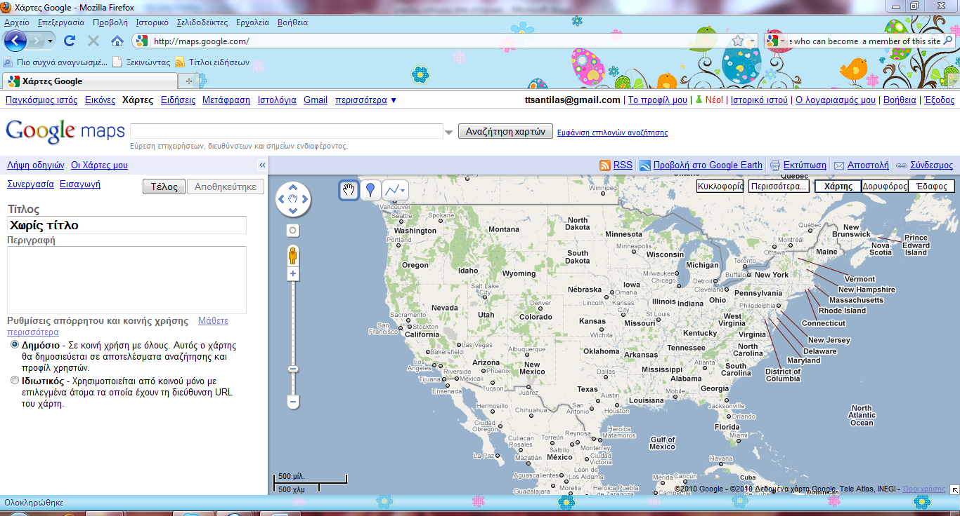
- Click Start or Create New Map.

- Name your map, e.g.The World’s Largest Cocoa Countries / The World’s Largest Tea Countries / The World’s Largest Banana Countries / The World’s Largest Coffee Countries.
- Click Unlisted.
- Click Save.
Now you can add more information on your map.
- In the Search box, type the name of the 1st country you want to add and click Search.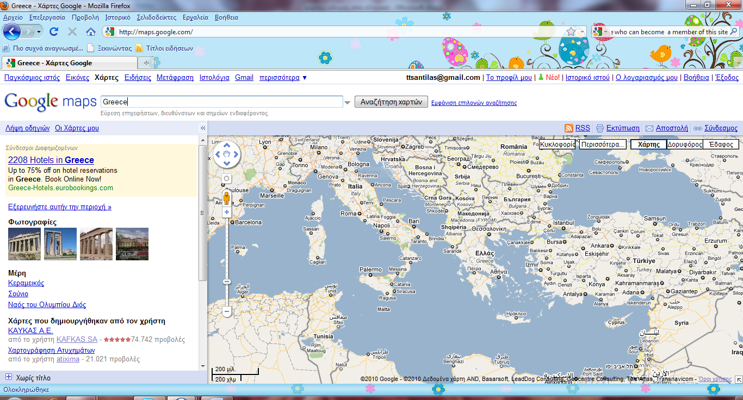
Now you are taken to the country you selected.Τo place that country on your map:
- Click My Maps on the left.
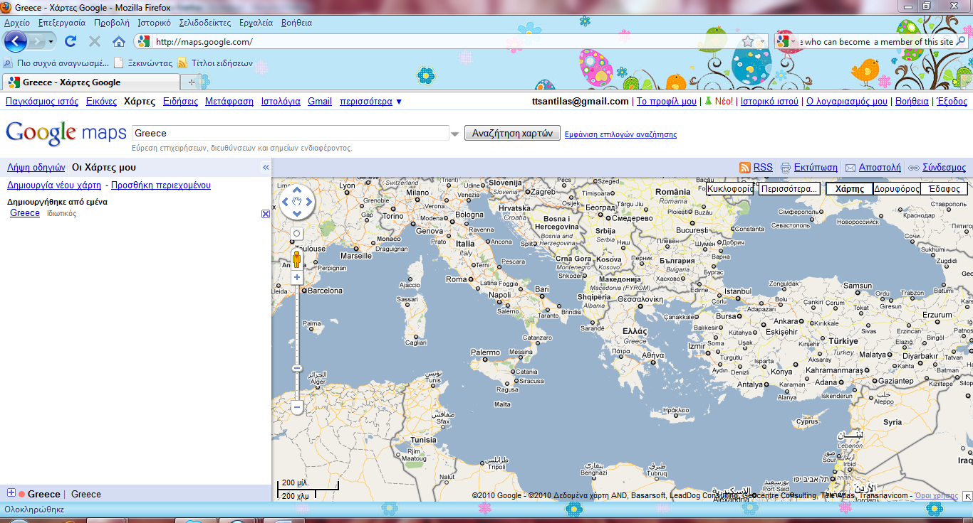
- Click on the name of your map.
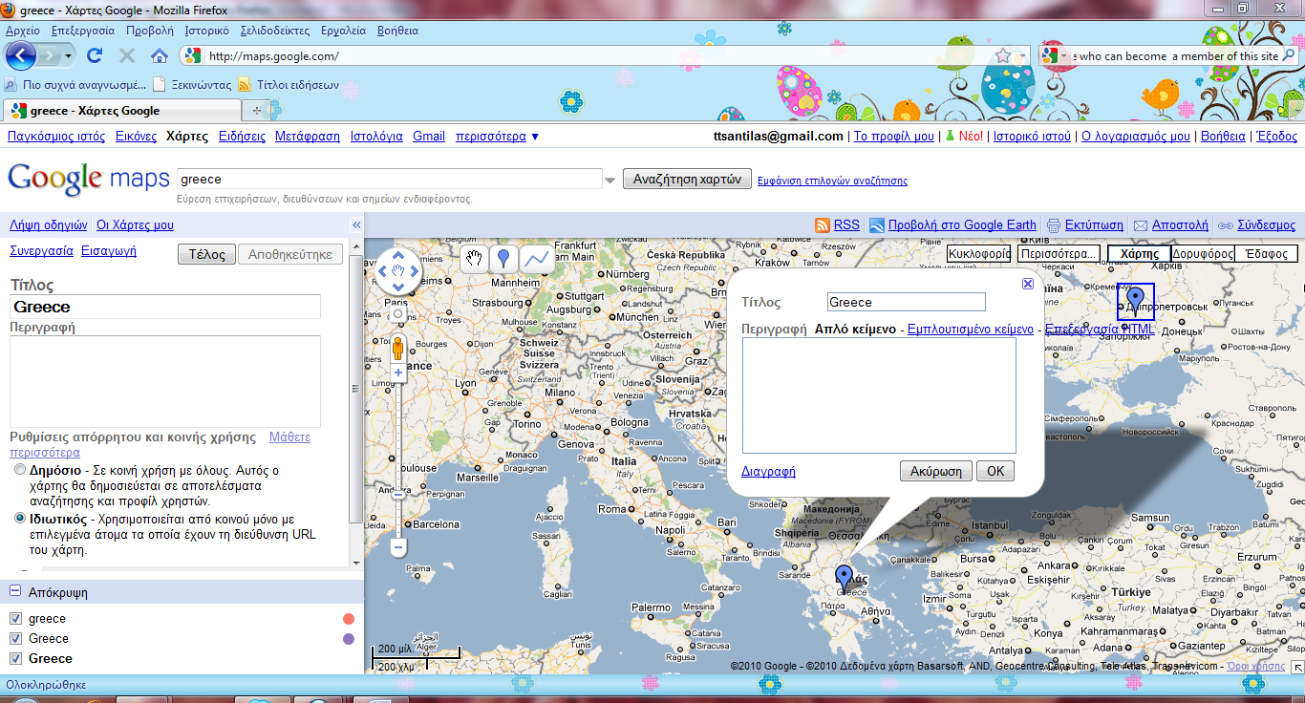
- Click the “placemark tool” .
- Click on a place in the country you want to add to your map.
- Type the name of your country in the box and click ΟΚ.
Go on the same way for all the countries you want to add.
In the Search box type in the name of the 2nd country you want to add and click Search.
Now you are taken to the country you selected.Τo place that country on your map:
- Click the “placemark tool” .
- Click on a place in the country you want to add to your map.
- Type the name of your country in the box and click ΟΚ.
Go on the same way for all the countries you want to add.
After you have added all the countries on your map, click Finish.
